Task ##P/C – Spike: [Core 1 – Software development for mobile devices – COS30017]

Goals:
- This app is a simple one-activity game that makes use of layouts and localisation.
- On completion of this task, I will demonstrate that I am able to work with a single activity app, handle activity states, use Logs, create layouts, implement listeners effectively and enable localisation.

Tools and Resources Used
- Android Studio
- Website google developer
- Github

Knowledge Gaps and Solutions

Gap 1: Be able to create two layouts for the app, portrait, and landscape. Using linear and constrain lay out
- Be able to add another landscape layout
- Be able to use LinearLayout using layout_weight
- 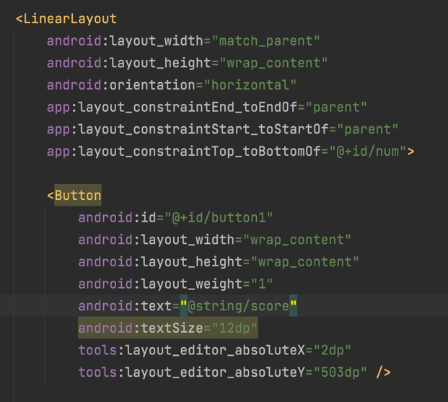
- Be able to use ConstrainLayout
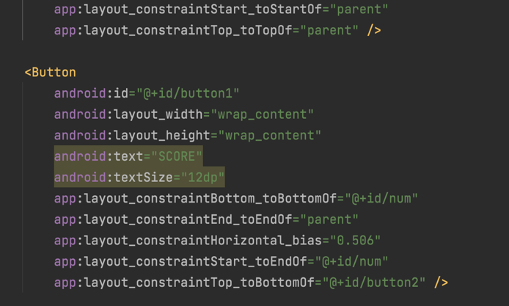

Gap 2: Be able to use saveInstanceState to save the score
- Be able to save instance state with a key pair
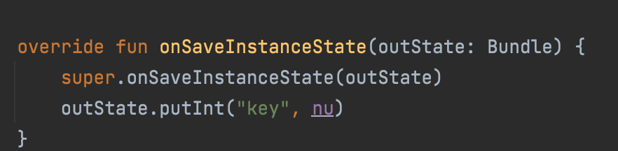
- Be able to restore instance state
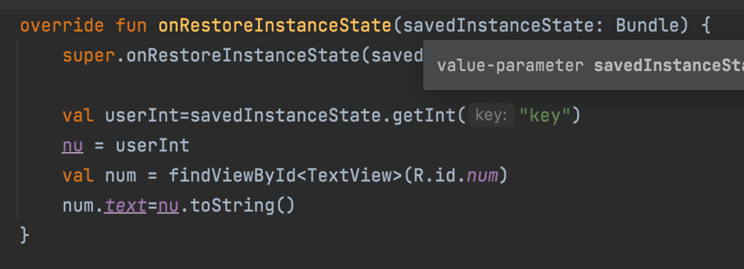

Gap 3: Be able to use when to change text color and play sound
- Be able to use when for different cases.
- Be able to change text color
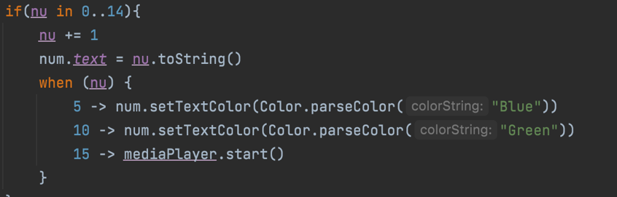
- Be able to play sound which was saved in raw

Gap 4: Be able to add a language to the project
- Be able to add string to String.xml
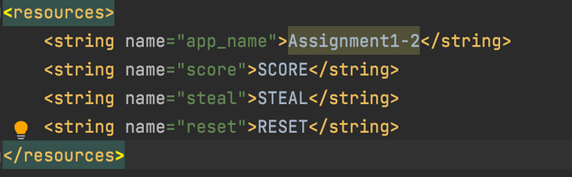
- Be able to add another language
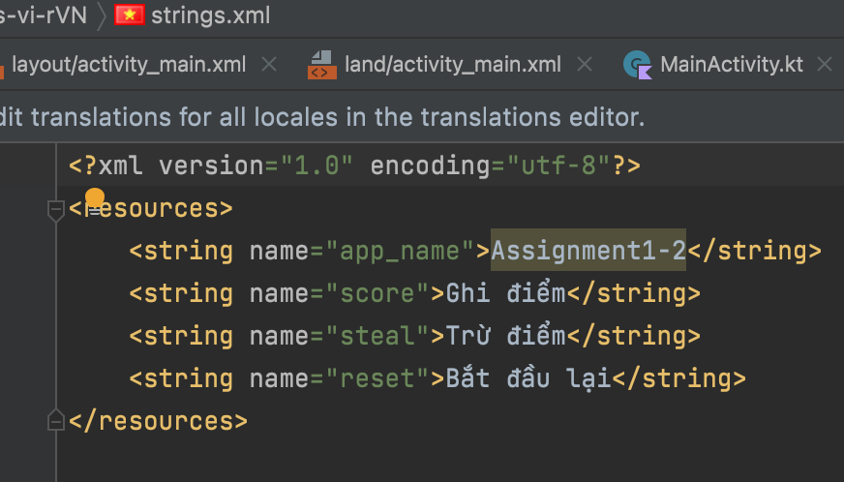

Gap 5: Be able to use Log
A log is a record of what has happened. Typically it helps to diagnose problems or get certain insights on what is going on in an application’s life cycle.
When rotating the screen, I use logs to check and realize that the activity is destroyed, and then recreated.
And since, I can check whether the point is saved using instance state.

Open Issues and Recommendations
This section outlines any open issues, risks, and/or bugs, and highlights potential approaches for trying to address them in the future.

…

